**CDS DS 561 – Cloud Computing**

**Assignment - 1**

**Vishwas Bhaktavatsala**

[**vishwasb@bu.edu**](mailto:vishwasb@bu.edu)

**U74206902**

**Cloud Console**

Project Creation

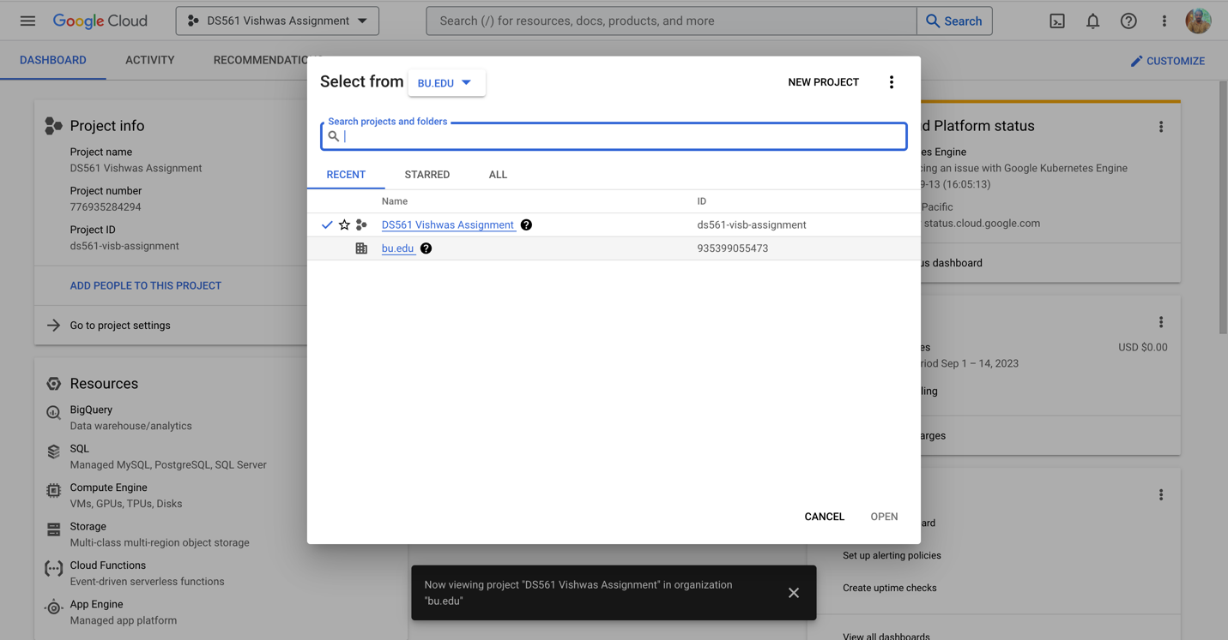

**Step 1: Creating a Basic Storage Bucket**

**Task 2: Creating a directory in the bucket**

**Task 3: Copy a file into the created directory**

**Task 4: Delete directory and the folder inside it in one operation**



**Task 5: Make a VM (Compute Engine)**

**Task 6: Pause the VM**

**Task 7: Delete the VM**

**Task 8: Create a Service Account and provide permissions for the storage bucket.**

**Task 9: Delete Service Account**

**Task 10: Delete the Storage Bucket**

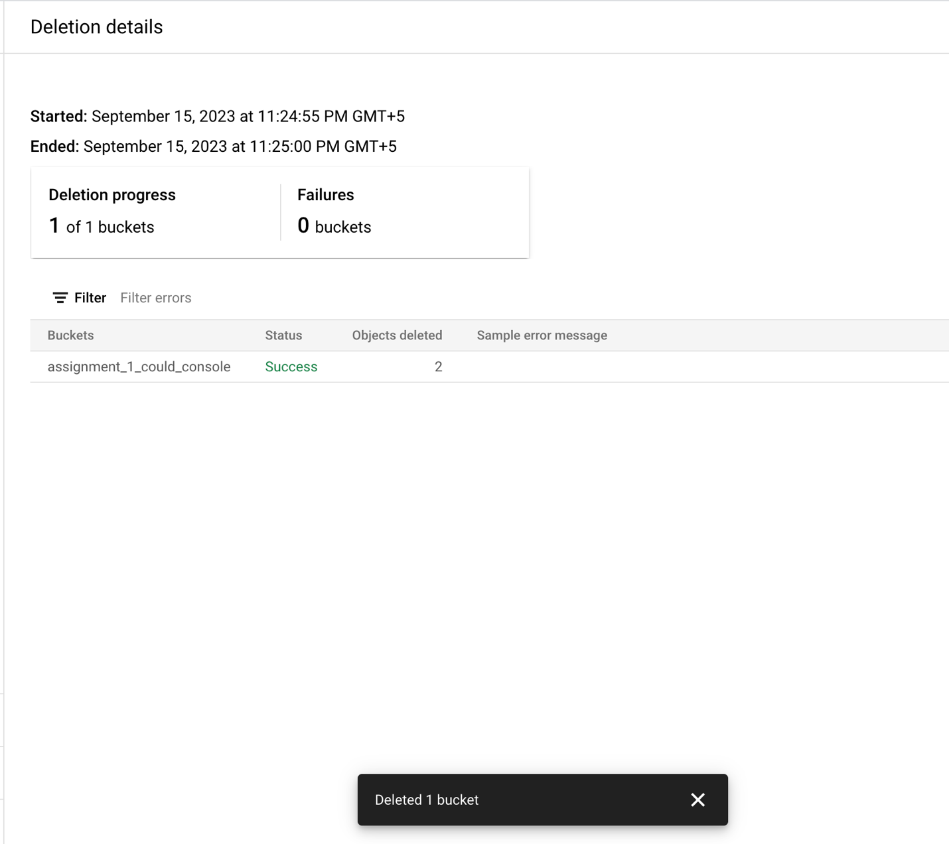

**Gcloud:**

**Installation and Initialization of gcloud on Mac**

**Commands Used:**./google-cloud-sdk/install.sh

gcloud init

**Task 1: Create a Storage Bucket**

Command:

gcloud storage buckets create gs://assignment1-bucket-gcloud --project=ds561-visb-assignment --default-storage-class=NEARLINE --location=US-EAST1 --uniform-bucket-level-access



**Task 2 & 3: Create a Directory under the bucket and copying a file into the folder**

Command:

gcloud storage cp ./schedule.png gs://assignment1-bucket-gcloud/FolderCreatedByGCloud/

**Task 4: Deleting the folder and the file inside it in a single operation**

Command:

gcloud storage rm -r gs://assignment1-bucket-gcloud/FolderCreatedByGCloud



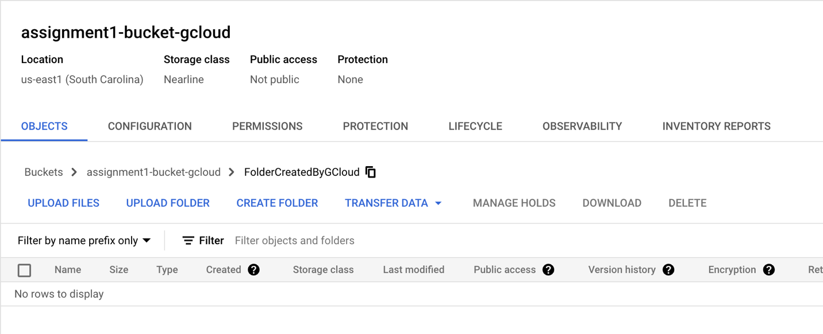

**Task 5: Create a VM**

Command:

gcloud compute images list

gcloud compute images describe debian-11-bullseye-arm64-v20230912 --project=debian-cloud

gcloud compute instances create assignment-vm-gcloud \

--image=debian-11-bullseye-arm64-v20230912 \

--image-project=debian-cloud \

--machine-type=e2-medium \

--zone=us-central1-a

gcloud compute instances describe assignment-vm-gcloud

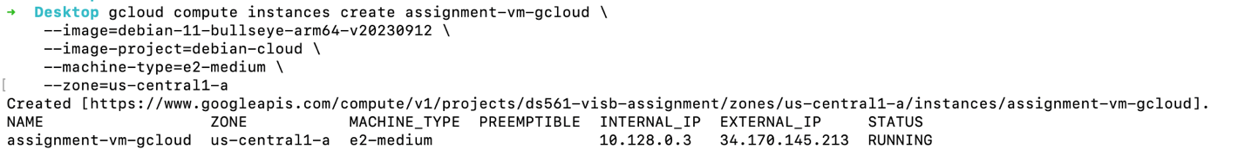

**Task 6: Pause a VM**

Command:

gcloud compute instances suspend assignment-vm-gcloud --zone=us-central1-a

**Task 7: Delete a VM**Command:

gcloud compute instances delete assignment-vm-gcloud --zone=us-central1-a



**Task 8: Create a Service Account and give the permissions to the Storage Bucket**

Command:

gcloud iam service-accounts create assignemnt1-sa-gcloud \

--description="Service Account created via gcloud for Assignment 1" \

--display-name="Assignment SA GCloud"

gcloud projects add-iam-policy-binding ds561-visb-assignment \

--member="serviceAccount:assignemnt1-sa-gcloud@ds561-visb-assignment.iam.gserviceaccount.com" \

--role="roles/storage.admin"

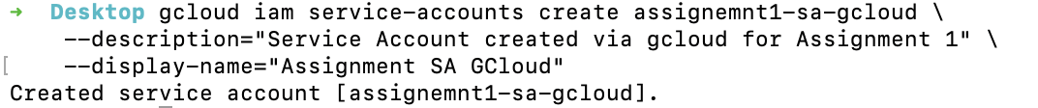

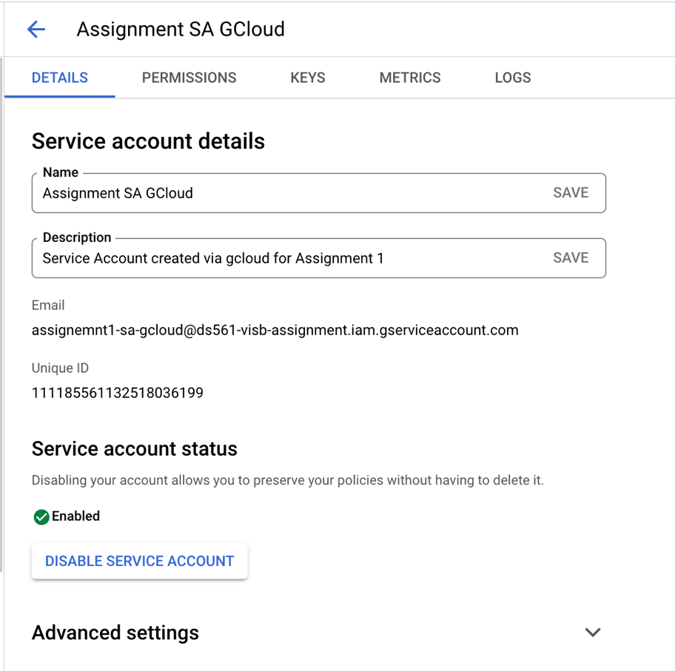

**Task 9: Delete the Service Account which was created**

Command:

gcloud iam service-accounts delete \

[assignemnt1-sa-gcloud@ds561-visb-assignment.iam.gserviceaccount.com](mailto:assignemnt1-sa-gcloud@ds561-visb-assignment.iam.gserviceaccount.com)

**Task 10: Delete the Storage Bucket which was created**

Command:

gcloud storage rm --recursive gs://assignment1-bucket-gcloud/

**GSUtil**

**Task 1: Create a Storage Bucket**

Command:

gsutil mb -p ds561-visb-assignment -c NEARLINE -l US-EAST1 -b on gs://assignment1-bucket-gsutil



**Task 2 & 3: Create a Directory under the bucket and copying a file into the folder**

Command:

gsutil cp ./Desktop/schedule.png gs://assignment1-bucket-gsutil/FolderCreatedByGSUtil/



**Task 4: Delete the Folder and all the contents in it in one operation**

Command:

gsutil rm -r gs://assignment1-bucket-gcloud/FolderCreatedByGSUtil



**Task 10: Delete the Storage Bucket**

Command:

gsutil rm --recursive gs://assignment1-bucket-gsutil/



**Gsutil** is a tool which can be used to work with Storage Bucket only. This tool provides the required functionality to allow us to access cloud storage via command line, like, create, delete, upload , download and many such operations. This tool cannot be used to perform other actions such as creating a VM or deleting a VM. Therefore all the other tasks which were provided cannot be performed using this tool.